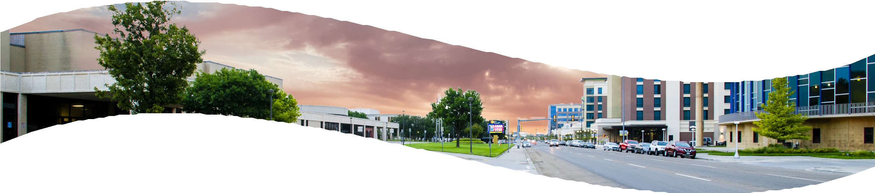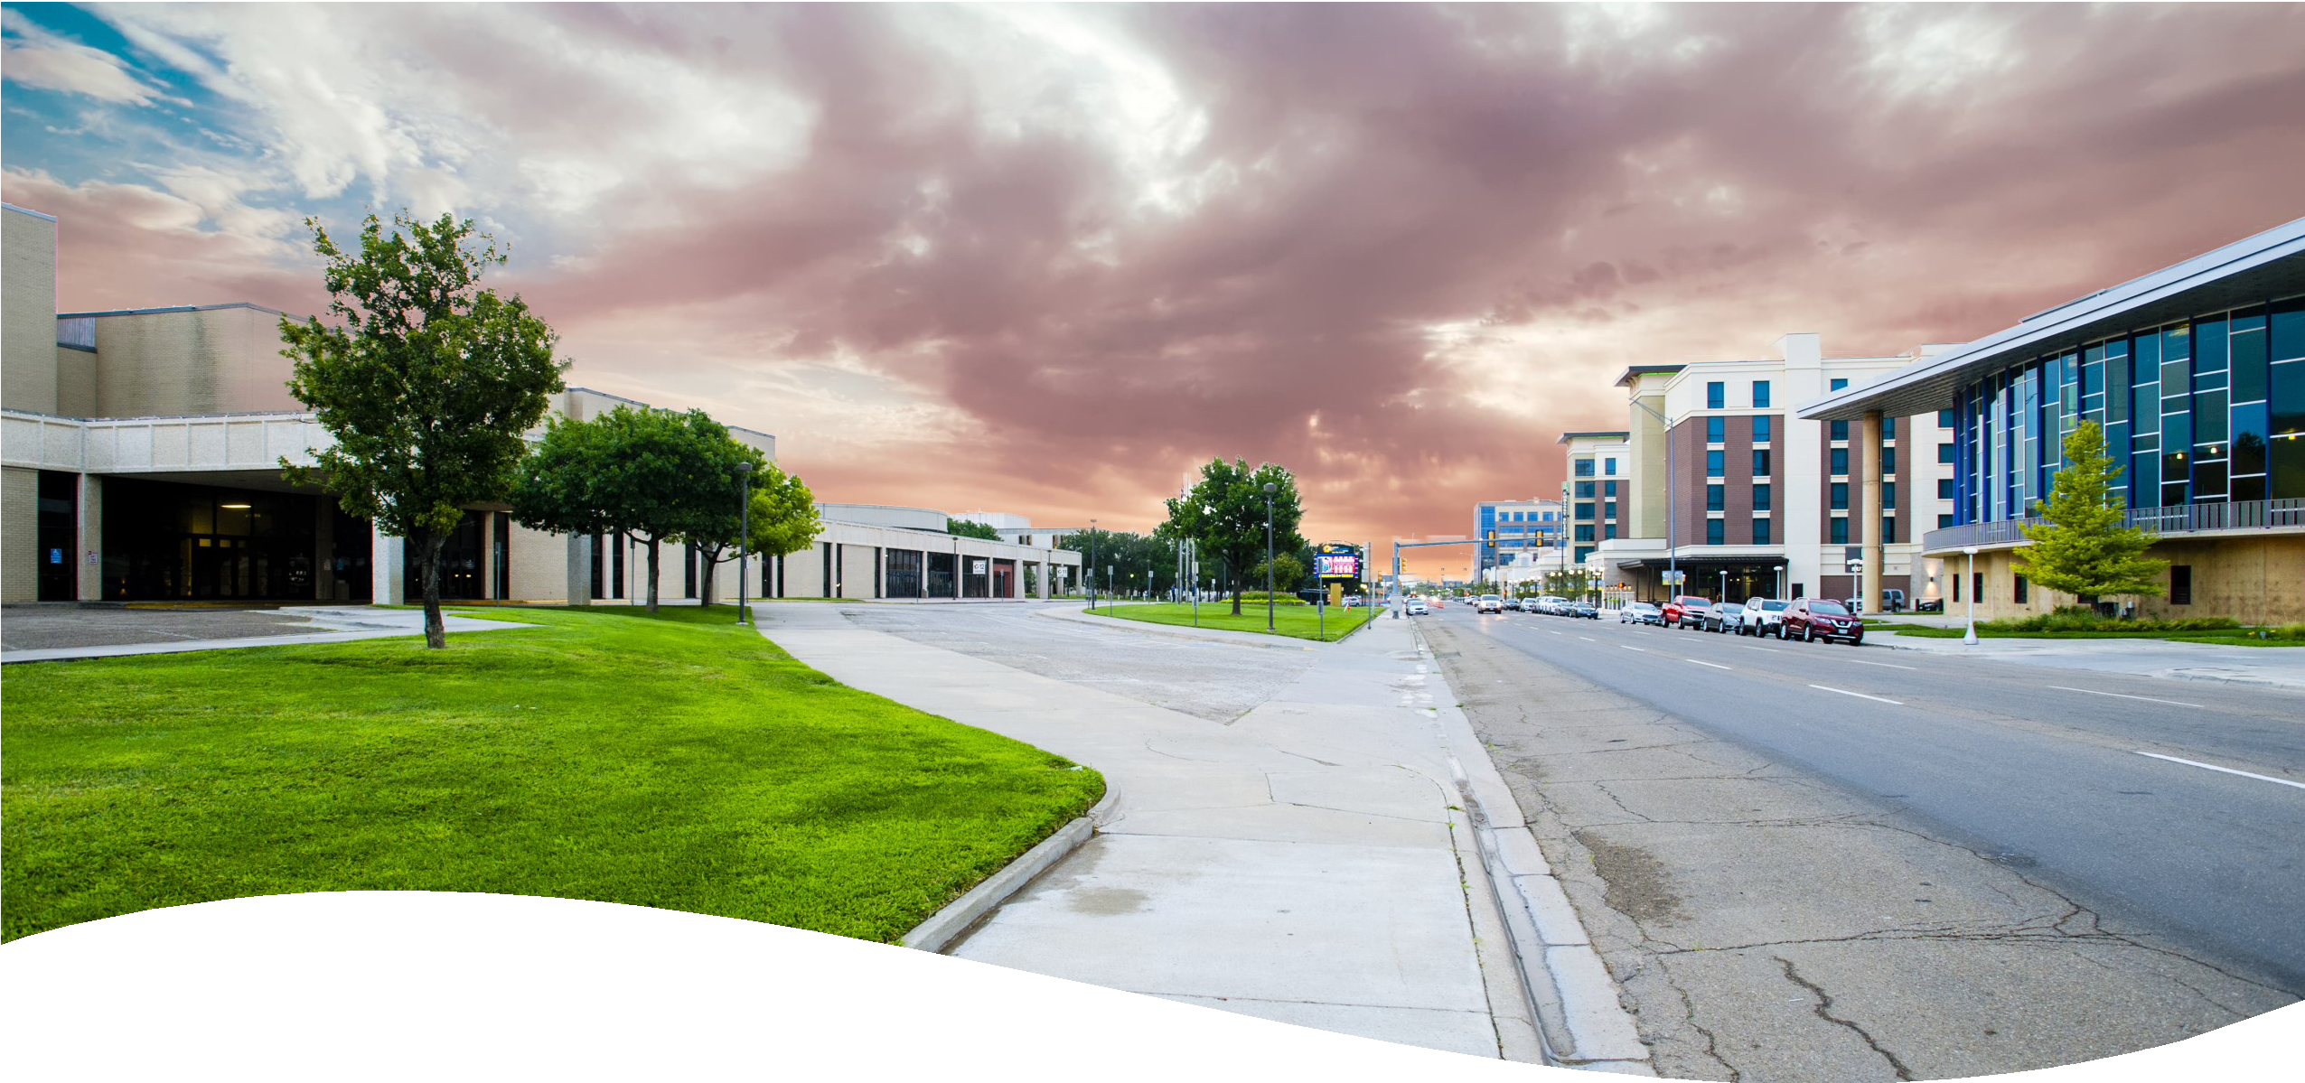

Event Planning Guide



Table of Contents
General Information & Staff 3
Directions & Parking 4
Parking Map 5
Event Planning Process 6
Event Planning Check List 7
Event Planning Services 8
Marketing & Publicity 12
Decorating Guidelines 13
Catering Guidelines 16
Equipment Rental Rates 18
Audio / Visual Equipment Rental Rates 19
Sound Package Rates 19
Labor & Services Rates 21
For a listing of available spaces, please visit us at www.amarillociviccenter.com

Amarillo Civic Center
401 S. Buchanan St.
Amarillo, Texas 79101

General Information

Globe-News Center for the Performing Arts
500 S. Buchanan St.
Amarillo, Texas 79101

ACCC Mailing Address
P.O. Box 1971
Amarillo, Texas 79105

Administrative Office
Monday - Friday 8 am to 5 pm
(806) 378-4297
Additional Contacts

To book an event, or with questions about rental fees, insurance, or payments:
Booking - (806) 378-9321

To coordinate your event, arrange a client tour, or ask questions about room set-up/needs:
Event Services - (806) 654-1719

For audio/visual equipment, stage needs, lighting, or stagehand information:
Production - (806) 378-3088

For concessions, food, beverage, or bar information:
Cork Screw Foods - (806) 418-2531

For Wi-Fi or other internet information:
Assistant General Manager - (806) 378-9480

For marketing or advertisement information:
Marketing Administrator - (806) 378-4246

For box office or ticketing information:
Box office – (806) 378-3096

For a listing of staff contact information, please go to www.amarillocivicenter.com

For any questions not otherwise listed, please contact our main office at (806) 378-4297.

Via I-40 East

Directions & Parking

Take Exit #70 (Downtown / North US 287 / 87)
Bear right and continue onto Buchanan Street
Continue on Buchanan Street to the Amarillo Civic Center Complex
Via I-40 West
Take Exit #70 (Downtown / North US 287 / 87)
Bear left and merge onto northbound US 287 / 87 Bear right and merge onto Buchanan Street
Continue on Buchanan Street to the Amarillo Civic Center Complex

Via US-287 North
On US 287 / 87 southbound, proceed south to Downtown Bear left and merge onto Pierce Street
Turn left to SE 4th Avenue, which ends at the Amarillo Civic Center Complex

Via I-27 South
On I-27 northbound, proceed north to Downtown Bear right and continue on Buchanan Street
Continue on Buchanan Street to the Amarillo Civic Center Complex

Some routes may become inaccessible due to downtown traffic and construction. The Complex posts updates to our website as they become available. Please visit our Parking Information page located at http://amarillociviccenter.com/about/parking-information for more information.

RV parking is available in the lot off Johnson Street, directly east of the Complex Administrative Office. RV parking is on a first come, first serve basis and spaces are limited. Rules and regulations apply. Prices for that are as follows:
$15.00 / per day including power; no water
$40.00 / per event including power; no water

Please call the Amarillo Civic Center Administrative Office at (806) 378-4297 for questions about RV parking. The office is open Monday – Friday from 8:00am – 5:00pm.

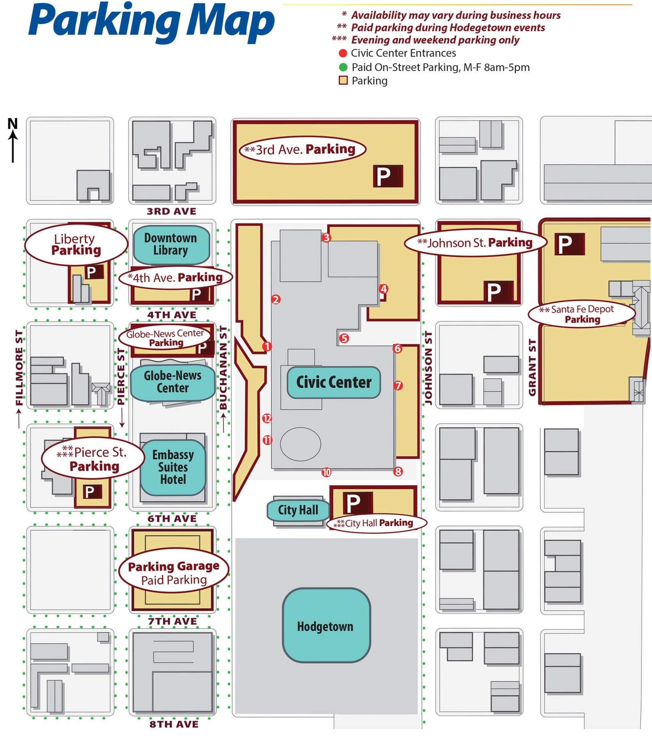

Event Planning Process

Planning your event with the Amarillo Civic Center Complex is an easy process! Our dedicated and experienced staff are here to make sure that your event is a stress-free success.

Step 1: Come say hi!
- If you’re unfamiliar with the facilities, meet with an Event Supervisor to tour the building and determine which spaces would be appropriate for your event and find out what services are available in-house.
- Please call the Event Services Cell Phone at (806) 654-1719 to schedule an appointment to ensure the room is available. Tours are not conducted of rooms when they are leased to other clients.

Step 2: Work with the Event Booking Coordinator to secure your space and dates.
- Call the Event Booking Coordinator during office hours to book your rooms. Rooms may be tentatively held without a deposit, but a deposit is required to secure your booking.
- A lease agreement will be drawn up and sent to you via e-mail. This must be signed and returned as soon as possible, along with your deposit.
- A certificate of liability insurance is also required prior to your event. The Event Booking Coordinator can give you details about the requirements as well as suggestions for local companies which can provide the necessary insurance certificate.

Step 3: Coordinate with the Marketing Administrator on public details.
- Once your event is booked, the Marketing Administrator will reach out to you on details needed for the Complex website event calendar and any publicity materials needed.
- Try to have your event details hammered out by this time such as the event start and end times, any ticket prices, a point of contact for patrons with questions, any graphics to use for advertisement, etc.

Step 4: Work with your Event Supervisor to coordinate Complex details and needs.
- Approximately a month and a half before your event, an Event Supervisor will be assigned to assist you with coordination. You are also welcomed to speak with any Event Supervisor when you are ready to begin coordination before and after this time.
- Event Supervisors are available via the Event Services Cell Phone at (806) 654-1719 from 7:00am until approximately midnight each day (except City of Amarillo holidays).
- Your Event Supervisor will work with you to create a floor plan of your event in your leased space and schedule all equipment and labor needed (tables and chairs, AV equipment, technical labor, ushering services, etc.).
- Your Event Supervisor will gather all event information and distribute it to our internal operating departments to ensure everything is ready upon your event date.
- They can also work alongside you to ensure any third-party vendor (production companies, decorators, caterers, etc.) assisting with your event complies with all Complex rules and regulations.

Event Planning Check List

1-2 Months Prior to Your Event:

⇒ Provide Event Booking Coordinator with certificate of liability insurance, signed lease agreement, and required deposits.
⇒ Contact the Event Booking Coordinator and Marketing Administrator to provide final answers for Event FAQ Sheet and any publicity details.
⇒ Meet with assigned Event Supervisor to begin planning your event if you haven’t already.
⇒ Contact Corkscrew Foods for any alcohol or concessions services. Their contact information is in the Event Planning Services section, under Bars and Concessions.
⇒ Begin to coordinate with third-party vendors such as caterer, band/DJ, decorators, production companies, etc. if you haven’t already.

2-3 Weeks Prior to Your Event:

⇒ Finalize event floor plans with your Event Supervisor.
⇒ Obtain estimated invoice for outstanding balance, equipment rental, and services from your Event Supervisor. Payment may be required in full prior to your move in.
⇒ Provide final event details to your Event Supervisor such vendor list, move in times, internet/telephone needs, electrical requirements, etc.
⇒ Confirm bar placement and bar times with both Corkscrew Foods and your Event Supervisor, if applicable.
⇒ If using any A/V equipment, technical labor, or lighting from the Complex, confirm this with your Event
Supervisor and the Production Management team.
⇒ Provide your Event Supervisor with an itinerary for your event.
⇒ Provide your Event Supervisor with requests for room marquees, if applicable, such as text, font, colors, logos, or other images.

1 Week Prior to Your Event:

⇒ Check in with your Event Supervisor to go over any final questions or needs.
⇒ Confirm all set-up needs, services, and floor plans provided by the Complex.

Event Planning Services
This section of the Event Planning Guide will provide useful information on key areas instrumental to the implementation of your event at the Amarillo Civic Center Complex.

Audio/Visual (A/V) or Production Needs
You may select the audio/visual provider or production company of your choice. However, the Amarillo Civic Center Complex does have an in-house Production Management team that can offer select services including microphones, basic audio equipment, lighting services, technical labor, and more. The complex does not provide projectors or any cords or cables that go with it. You will need to bring all accessories for your projector and someone who can set it up and run it. If you would like a list of local A/V providers or production companies, please ask your Event Supervisor.

Bands, DJs, Decorators, Florists, Photographers, Caterers, & Other Third-Party Event Vendors
You may select the vendors of your choice to provide these services for your event. Once you’ve selected your event vendors, please notify your Event Supervisor who you’ve selected, if they have any needs from the Complex (such as additional power for a DJ), and their contact information. Some rules and regulations may apply. The complex does not provide tablecloths, linens, chair covers, decorations, or catering equipment. The Complex concessionaire, Corkscrew Foods, has some catering capabilities which must be requested from their manager.

Bars & Concessions
Corkscrew Foods (CSF) is the in-house concessionaire and the TABC license-holder for the Complex. To have any alcohol present at your event, you must contact the CSF manager to arrange your request. We require Commissioned officers to be present at events where alcohol is present. Officers are scheduled to arrive 30 minutes prior to the scheduled bar opening time, and they stay through the event until 30 minutes after the event ends. Your Event Supervisor will schedule bar security for you once bar times have been confirmed with them and with the CSF manager, and the cost will be applied to your final invoice.

Corkscrew Foods (CSF)
CSF Manager: Melody Flanagan
(806) 418-2531 mflanagancc@gmail.com

Kitchens & Food Preparation
The Grand Plaza, Heritage Room, and North Exhibit Hall each have adjacent prep kitchens available for lease at an additional cost. No cooking is allowed inside of the facility. These kitchens allow your caterer the capability of storing, cooling, warming, prepping, and cleaning on-site during your event. There are also smaller warming kitchens available for lease in the Headliner Room and at the Globe-News Center for an additional cost.

Electrical Needs
All rooms are equipped with standard 110-volt wall outlets free of charge. Any greater power needs must be communicated to your Event Supervisor in advance so that they can coordinate with the City of Amarillo Facilities Department or Complex Production Management team. Electrical needs greater than standard 110-volt wall outlets are subject to additional fees.

Equipment Rental
The Complex is equipped with an inventory of standard tables and chairs to meet your requirements. Certain sizes and styles are carried in-house, so communicate your needs with your Event Supervisor to see if any specialty items will need to be arranged through a third-party vendor. Additional items such as dance floors, lecterns, staging, easels, coat racks, and more are available for rent. Please note that equipment rental is NOT included in your room rent or lease agreement.

Expenses
The rental fee quoted to you by the Event Booking Coordinator is for the room rental and deposit ONLY. Additional equipment rental, labor, services, and expenses shall be outlined by your Event Supervisor once final event requirements are provided. Payment in advance may be required.

Fire Code
The Amarillo Civic Center Complex complies with all state and local fire code ordinances. As you are planning your event set-up with your Event Supervisor, please keep fire code in mind. This means that aisles of the appropriate size must be left clear for your attendees and others to walk through. Doors marked with exit signs must also be left clear with an aisle the width of the doors to them. No aisles or exits may be obstructed at any time, for any reason. Fire extinguishers and AEDs are located throughout the Complex and must also be kept clear in the event of an emergency.

First Aid/Emergency Services
The Amarillo Civic Center Complex Event Staff are trained and certified in first aid, CPR, and AEDs. Should something occur that requires immediate assistance, call 911 first. Let them know what entrance they should go to when they arrive. After speaking to emergency responders, call the Complex Event Services Cell Phone at (806) 654-1719 and provide as much information as possible. First aid is available for minor incidents as well if you or any of your event attendees need assistance.

Floor Plans & Diagrams
Your Event Supervisor will work with you to create a floor plan of your event set-up using the Social Tables event diagramming software. This service is provided free of charge to every event taking place in the Complex. Please ensure that you have provided written or e-mail confirmation of the final floor plan to your Event Supervisor no later than 1 week prior to your scheduled move in. This floor plan will be used to create your invoice and given to the building crew so they can prepare your event set-up. These diagrams will be used to set your room for the event, which will be completed by 7 a.m. on the morning of your leased period. Changes can be made on site by contacting the Event Supervisor cell phone.

Insurance
All events at the Amarillo Civic Center Complex are required to provide liability insurance. When obtaining insurance, the Certificate Holder and Additional Insured must state the City of Amarillo, not the Amarillo Civic Center Complex. The certificate must ensure the event for up to $1 million in liability coverage and additional coverage may apply depending on the nature of your event. Please contact the Event Booking Coordinator for any questions about insurance including coverage requirements, a list of providers, and more.

Internet Connections
Complimentary public Wi-Fi is available throughout the Civic Center and Globe-News Center. The wireless network is titled “Civic Center – Guest.” To access the public Wi-Fi, connect your device to this network and then open a web browser or internet app. This will prompt a splash page to come up with the internet use policy. Dedicated hardline and advanced Wi-Fi services are available for an additional cost. Please talk to your Event Supervisor about these needs and applicable pricing.

Lighting
All rooms at the Civic Center and Globe-News Center are equipped with standard overhead lighting. The two ballrooms are equipped with incandescent dimmable room lighting and fixed-position stage lighting in addition to the conventional fluorescents. The Event Supervisor on duty during your load in will be more than happy to set a lighting look in your leased space to use throughout your event. Should you need the lighting to change from the set lighting look, such as to lower or raise the lights for a presentation, you will want to communicate this with your Event Supervisor immediately so that a dedicated Lighting Technician can be hired to assist you during your event. For questions about lighting and equipment in performance spaces (Cal Farley Coliseum, ACCC Auditorium, and Globe-News Center for the Performing Arts), please contact our Production Department.

Loading In and Out
Each leasable room at the Complex has a designated loading dock or zone. Your Event Supervisor will be able to let you know where this is located, how to access it, and any additional details. They will also let you know of any restrictions that may be in place due to other event traffic or facility needs. Please note that vehicle loading and unloading may not occur in public hallways while other events are in progress. It is also important to discuss move-in and out with the Event Booking Coordinator prior to finalizing your lease agreement to ensure you have booked the proper amount of time ahead of your event to accommodate moving in, setting up, and moving out. No clients, nor their vendors, may move in or occupy their event space prior to the time designated on their lease agreement.

Marquees – Outdoor & North End Room Entrances
There are LED marquees over the entrances of the room on the north end of the Civic Center. If you are using one of the rooms with an LED marquee above the entrance, your Event Supervisor will arrange to have the name of your event on display. If you would like to create custom marquee graphics, please contact your Event Supervisor for dimensions and other information.

Technical Labor
Technical Labor is available to assist you with any needs on-site such as audio, lighting, rigging, and more. There are some instances in which Technical Labor are required for events. Any event using more than 3 pieces of wired audio equipment, using any wireless audio equipment, or using more than one lighting look in the room must have a Lighting or Audio Technician hired for their event. Events using a band, DJ, or other performers who need power greater than standard 110-volt outlets or house sound tie-in are required to have a technician hired for their event to tie in and unite power and/or audio. Events that plan to rig from the ceiling of their event space may be required to hire Riggers for their event. Plans for rigging in a room must be discussed in depth with your Event Supervisor to determine what is allowed to be hung, what the weight limits for hanging are, if rigging can be done safely, and what Technical Labor requirements may apply. Events taking place in one of the three performance spaces (Cal Farley Coliseum, Civic Center Auditorium, or Globe-News Center) are required to have a minimum of three Technicians on-site throughout their event to assist with any technical needs. Please see the Labor & Services Rates page of this guide for more information about Technical Labor.

Utilities
The Amarillo Civic Center Complex will supply adequate levels of ventilation and overhead lighting necessary for your event. Our heating and air conditioning is controlled by computer and monitored to stay between 68° - 72°. Should you feel that it has fallen out of those parameters, contact an Event Supervisor immediately and they will assess the room. Events with specific temperature requirements must notify their Event Supervisor in advance, as arrangements must be made by another department to change computer- controlled set points. Water spigots are located on all docks and inside of the two exhibit halls, but a key must be obtained from the Event Staff on your event day. Your lease agreement covers the cost of utilities in your room rental rates.

Hours of Operation
The Complex’s normal hours of operation are 7:00am to midnight each day. If you wish to access the building earlier or later than this, you may book extended hours into your lease agreement. The extended hour fee is charged per hour and may only be booked up to 1 hour before 7:00am and 1 hour after midnight.

Deliveries
Any deliveries made outside of your event rental must be communicated to and approved by the Event Manager. There is limited space available for storage prior to your event and the Amarillo Civic Center Complex does not accept responsibility for any loss or damages incurred upon delivery. Please ensure all packages delivered to the facility are clearly marked with the name of the event and the intended recipient. Try to ensure packages arrive no more than 2-3 days prior to your scheduled move in. Any packages delivered to the facility for your event can be brought to your leased event space during your scheduled move in. Please ensure any packages left at the facility for pick-up are communicated to your Event Supervisor and have a Event Supervisor and have a shipping label clear and visible. The Amarillo Civic Center Complex will not cover the costs of shipping or receiving packages for events, so this must be arranged with your delivery company in advance.

Marketing & Publicity
This section of the Event Planning Guide will go over what sort of information you can supply for advertising purposes on our website and outdoor marquee. If you have images you would like to display on our outdoor marquee or website, please contact the Marketing Administrator.

Outdoor Marquee:
- The Amarillo Civic Center Complex has an outdoor marquee on Buchanan Street run by the Marketing Administrator, who will work with you to display information about your event, if you would like. Non-ticketed events will have their information displayed on the day of their event on the outdoor marquee. Ticketed event information will be displayed from the date of their on-sale until the date of their event.

Website:
- All events booked at the Complex will appear on the website’s List of Events and Calendar. Events
that do not wish to be listed must make this request through the Marketing Administrator.
- If you wish to advertise in any other capacity on the website, please contact the Marketing Administrator.

Posters:
- We can display up to 6 posters in display boards around the Civic Center. Posters should be 11” x 17” in size and contain contact or website information for patrons who would like to know more about your event. This must be arranged for through the Marketing Administrator.

Signage:
- Outdoor Directional Signage: You may post ONE sign on the west side, one sign on the north side, and one sign on the east side of the building for a total of THREE. The outdoor signs MUST be directional in nature (lists location or entrance guests should go to or have an arrow pointing in the right direction) to be posted outside.
- Indoor Directional Signage: Rules may apply. Please speak to your Event Supervisor for more info.
- Please make sure any signage posted is small, un-obstructing, neat, and professional looking.
- Please only use approved adhesive or other hanging devices per the Amarillo Civic Center Complex Decorating Guidelines.
- Complex staff reserve the right to remove and/or discard signage which does not adhere to these rules.

Decorating Guidelines
The following decorating guidelines have been set to maintain the appearance of our facilities and provide the same quality service to all clients. These guidelines are not all-encompassing, so clients with any questions or concerns about their décor should discuss their plans fully with an Event Supervisor to ensure all décor follows Complex policies. 806-654-1719.

For hanging banners or other décor throughout the Complex:
- No tape of any kind is allowed on any walls, curtains, columns, or the metal frames around the glass anywhere in the Complex. A high quality, transparent tape (such as Scotch tape) may be used to hang signs on GLASS surfaces.
- Clips, beeswax, decorator hooks, Command strips, and poster putty are acceptable for hanging banners or décor.
- Nails, staples, screws, or any other permanent mounting fixtures are NEVER allowed for any reason.
- The event client may be liable for any damages caused by hanging or mounting banners and décor. To avoid potential issues, please be sure to share these restrictions with event vendors.

For suspending items from the ceiling throughout the Complex:
- Only professional decorators, AV companies, or riggers may suspend items from the ceilings in the North Exhibit Hall, Heritage Room, Coliseum, Auditorium, Grand Plaza, or GNC Theatre. Please consult with an Event Supervisor to inform the Complex fully of what will be hung and ensure that all rigging requirements are understood and met.
- Nothing may be hung from the ceiling in the GNC Lobbies or GNC Education Room.
- All items hung in the South Exhibit Hall, Regency Room, Hospitality Room, north end Malls, Coliseum Concourses, and lower ceiling of the Grand Plaza must be hung with decorator hooks only.
- No décor of any kind may be hung from light fixtures, sprinklers, signage, or other permanently placed fixtures.

For decorating at the Globe-News Center for the Performing Arts:
- Due to the configuration of the Globe-News Center, the GNC Lobbies must not be set with table seating when an event is scheduled in the performance hall. Please consult with an Event Supervisor to discuss set-up needs prior to event move-in.
- The GNC Founder’s Lounge and Green Room are furnished areas for specific uses and may not be altered or used without expressed permission from Complex management.

For decorating in the Grand Plaza:
- No items may be placed inside of the fountains or planters in the Grand Plaza at any time for any reason.
- No rigging is permitted in the Grand Plaza Ballroom from the ceiling or light truss. Lightweight décor is permissible from the ceiling structure, but this must be approved by Civic Center Management.

For running décor or AV requiring cables or extension cords:
- Gaffer’s tape and painter’s tape are the only acceptable tape for affixing cords and cables to the floor or
carpet. Duct tape and packing tape are NEVER allowed.
- All cables and cords run through walkways, aisles, or doorways must be firmly taped or properly covered. Mats and cable ramps are acceptable for covering cords if an event client or vendor can furnish their own. The Complex has a small number of cable ramps; please consult with an Event Supervisor for availability.

⇒ The Complex can provide some lighting, audio, and video equipment and services in house. Please consult with an Event Supervisor to discuss event lighting, audio, and video needs PRIOR to move in, as some equipment and services require the hiring of a technician and equipment rental rates may apply.

⇒ The Complex does not loan out ladders. Event clients must furnish their own ladder to access heights if needed. Chairs and any other equipment may not be used in lieu of a ladder to ensure the safety of our clients, patrons, and employees.

⇒ The Complex does have scissor lifts, manlifts, and forklifts available for rent. The rental of scissor lifts, manlifts, and forklifts are subject to availability depending on Complex staff and other event needs. Consult with an Event Supervisor prior to event move in to discuss availability and applicable rental rates and/or labor. Scissor lift may not be driven across any portable dance floor or taken outdoors.

⇒ No helium-filled balloons are allowed inside the Complex at any time. Balloon arches, columns, and other décor are acceptable so long as they are not filled with helium. Consult your Event Supervisor for questions about balloons.

⇒ Décor which can cause large messes that are difficult to clean is prohibited. Examples of these types of
décor include sequins, glitter, confetti, hay, tumbleweeds, peanuts, etc. Please consult your Event Supervisor about décor plans to ensure all décor is within Complex guidelines. Any excessive messes left behind by unapproved décor may result in the event client being charged for cleaning fees.

⇒ The use of candles is permitted provided that ALL candles are in votives in which the flame does not extend past the top of the votive. No incense, sparklers, sage, or any other type of burning may occur within the Complex without the consent of Complex management and approval from the City of Amarillo Fire Marshal office.

⇒ No oil-based fog/haze of any kind is allowed anywhere in the Complex due to the sensitivity of fire detection systems. Water-based fog/haze is allowed in the Grand Plaza, Coliseum, Auditorium, and GNC Theatre but must be approved by an Event Supervisor or Complex management prior to the event.

⇒ Absolutely no décor or items may be placed in the stairwells around the Coliseum, Auditorium, or GNC to prevent impeding ingress and egress.

⇒ Doors marked as emergency exits and doors with exit signs above them may not be blocked at any time for any reason per Fire Code. An aisle the width of the entire exit must be left leading to the door if any objects or décor is placed near these doors. Consult with an Event Supervisor if blocking an exit is being considered to discuss alternative solutions if possible.

⇒ Event clients are responsible for ensuring all decorations and items brought into the Complex are removed following their event including the hooks, signs, banners, tape, etc. Please clearly mark any trash left behind after events have ended. The Complex is not responsible for any items left behind following an event.

⇒ Event clients are responsible for any messes or damages left behind after an event. Cleaning charges and/ or damage fees may be applied to the event invoice if messes or damages are found left after an event is over. Consult with the Event Supervisor on duty prior to leaving to do an inspection to ensure that the room is being left in a satisfactory condition and no items have been left behind.

Catering Guidelines
All caterers will need to meet with an Event Supervisor upon arrival at the facility. Caterers must also meet with an Event Supervisor prior to leaving the facility to conduct an inspection of the kitchen and all areas used for catering. All clients serving food at their event without the use of a caterer are responsible for these guidelines as though they were a caterer. Any damage, unclean areas, or items left behind will be noted and addressed during the inspection. If any damage, messes, or items are left behind without an inspection by the Event Supervisor, the client may be subject to cleaning fees or loss of their deposit. Each event client or caterer is responsible for the following:
- All caterers are required to adhere to all state and local health rules to provide services within the Complex. Please contact the City of Amarillo Environmental Health Department prior to the date of the event to ensure compliance with any of their rules. Clients who serve food at their event without the use of a caterer should also check with Environmental Health to ensure they are complying as well. The City of Amarillo Environmental Health Department can be reached at (806) 378- 9472.
- The event client MUST book the kitchen in their space to access the kitchen. The rental fee for a kitchen is $250.00 per day. Any event client or caterer who does not clean the kitchen after their event will be charged a $200.00 cleaning fee and will be required in the future to pay a $200.00 deposit, in addition to the rent. This deposit can be refunded on the invoice after the caterer satisfactorily cleans up after the event.
- If a client or caterer needs to use a room or kitchen for longer than the times allotted by the event lease agreement, the event client will be subject to additional extended hours fees.
- All kitchens at the Civic Center are prep kitchens only. Food may be stored, cooled, warmed, and prepared in the prep kitchens; NO COOKING OF ANY KIND may be done indoors. If an event client or caterer would like to cook on site outdoors, they may arrange to do so with their Event Supervisor PRIOR to their event.
- The North Exhibit Hall, Heritage Room, and Grand Plaza are equipped with prep kitchens at the Civic Center, though they must be rented in addition to leasing the event space. These kitchens are equipped with an industrial coffee maker, a walk-in cooler, two ice machines, four warming cabinets, two prep tables, a large dishwashing sink, and a small handwashing sink. NO FOOD OR GREASE IN SINKS. We do not have disposals and food and grease will clog drains and event may be subject to additional costs if sinks get clogged.
- No other rooms at the Civic Center have kitchens available.
- The kitchen at the Globe-News Center is a warming kitchen only. Food may be stored, cooled, warmed, and prepared in the kitchen, but NO COOKING OF ANY KIND may be done indoors.

Catering Guidelines
- All prep kitchens and areas where food has been served or prepared must be cleaned prior to leaving the facility after each use. Please ensure that all equipment used for catering has been turned off and cleaned.
- All items brought into the Complex by the caterer must be removed immediately after the event, per the event lease agreement. This includes all tablecloths, dishes, food, and decorations. If an event client or caterer wishes to leave any items for later pick up, this must be arranged and approved by an Event Supervisor prior to the event. The Event Supervisor will need to know what will be left, when it will be removed, and where it should be stored. This is subject to space availability and not guaranteed. The Amarillo Civic Center Complex is not responsible for items left behind after an event.
- Absolutely no additional heating sources are allowed to be used in the food warmer cabinets (i.e. sterno cans).
- Any exceptions to these guidelines must be approved by the Amarillo Civic Center Complex General Manager. For any questions regarding catering or the use of kitchens, please contact your Event Supervisor.
- Crockpots, electric skillets, slow cookers, chaffing dish warmers and coffee pots may be used with approval prior to the event from the Event Supervisor. These applications can draw significant power and may require dedicated outlets or adjusted circuit planning. If approved in advance, please also check in with the Event Supervisor the day of your event to review all electrical needs and confirm proper placement.
- Sterno cans are allowed to warm food for the event when placed on a stable non-flammable surface. All sterno setups must be kept clear of linens and décor.

The Sale of Food and Beverages

The Civic Center Complex policy on the sale or distribution of food and beverages by an outside source is as follows:

1. Any item that may be easily consumed on site may not be sold or given away outside the control of the Civic Center Complex’s contracted concessionaire. Items sold in bulk or for resale off the Civic Center premises will be allowed pending approval of Civic Center Complex Management. Authorized vendors will only be allowed to sell items in quantities of 8ozs. or greater in sealed packages. This includes but is not limited to candy, cookies, fudge, ice cream, caramel apples, nuts, and beef jerky.

2. No beverages are to be sold or given away outside the control of the concessionaire.

3. Any exception to this policy is by written approval Civic Center Complex Management. The above policy is in keeping with the contract between the City of Amarillo and the Civic Center Complex concessionaire. Please understand that it is the lessee’s responsibility to see that your vendors follow this policy. Lessees with vendors not in compliance with Civic Center Complex policy will be in violation of their contract and may be denied future bookings in the Amarillo Civic Center Complex. Vendors not in compliance may be required to leave. Thank you for your cooperation. If you have any questions concerning this policy, please contact our Concessionaire.

Corkscrew Foods (CSF)CSF Manager: Melody Flanagan
(806) 418-2531 mflanagancc@gmail.com

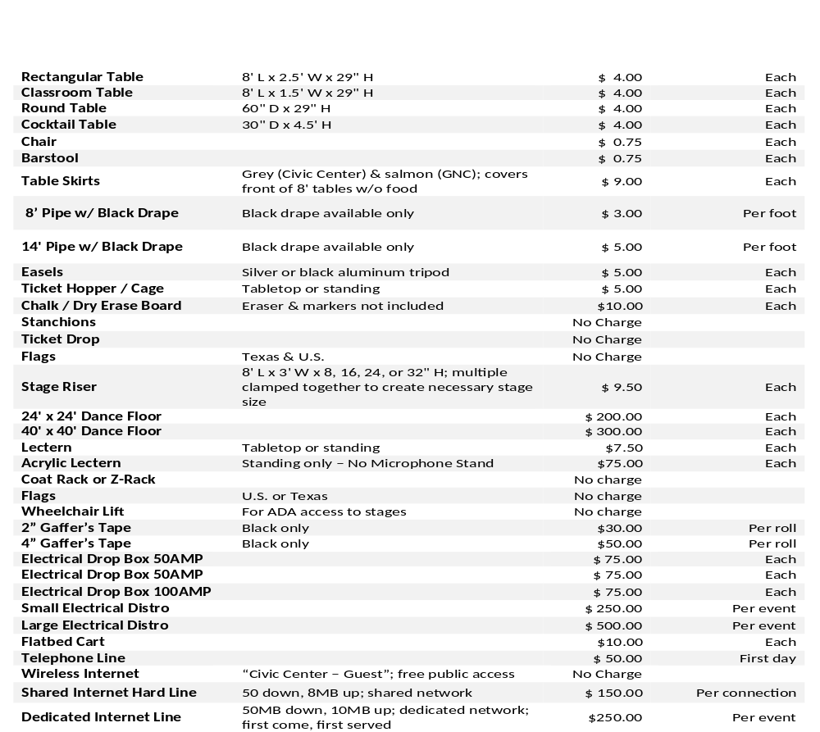
Equipment Rental Rates

Policies, rental rates, and equipment rental charges noted herein are subject to change without notice and supersede any
version of this guide. This Event Planning Guide and its contents are incorporated by direct reference to your Lease Agreement. Circumstances and operations not covered in these rules and regulations will be subject to interpretations, stipulations, and
decisions deemed necessary and appropriate by the Amarillo Civic Center Complex General Manager
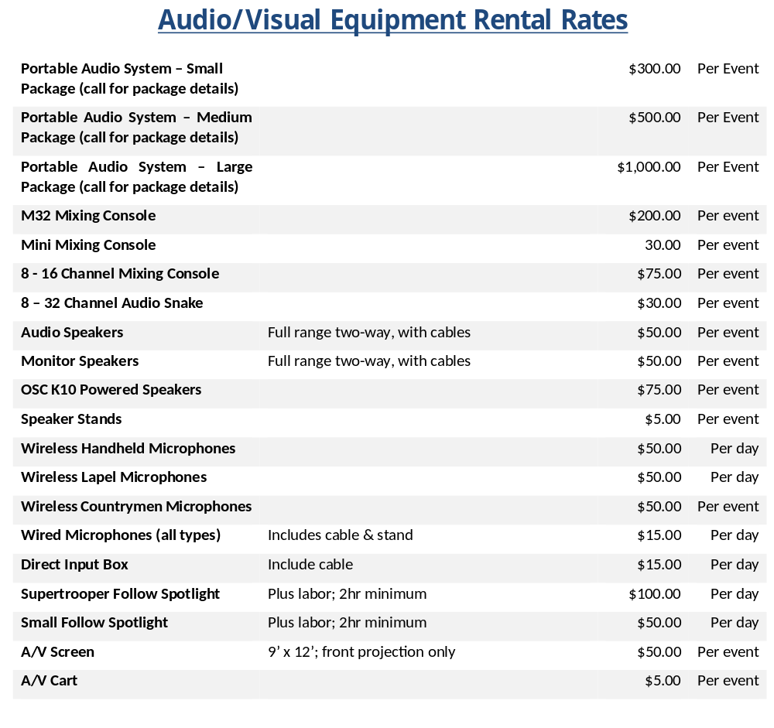

Policies, rental rates, and equipment rental charges noted herein are subject to change without notice and supersede any
version of this guide. This Event Planning Guide and its contents are incorporated by direct reference to your Lease Agreement. Circumstances and operations not covered in these rules and regulations will be subject to interpretations, stipulations, and decisions deemed necessary and appropriate by the Amarillo Civic Center Complex General Manager
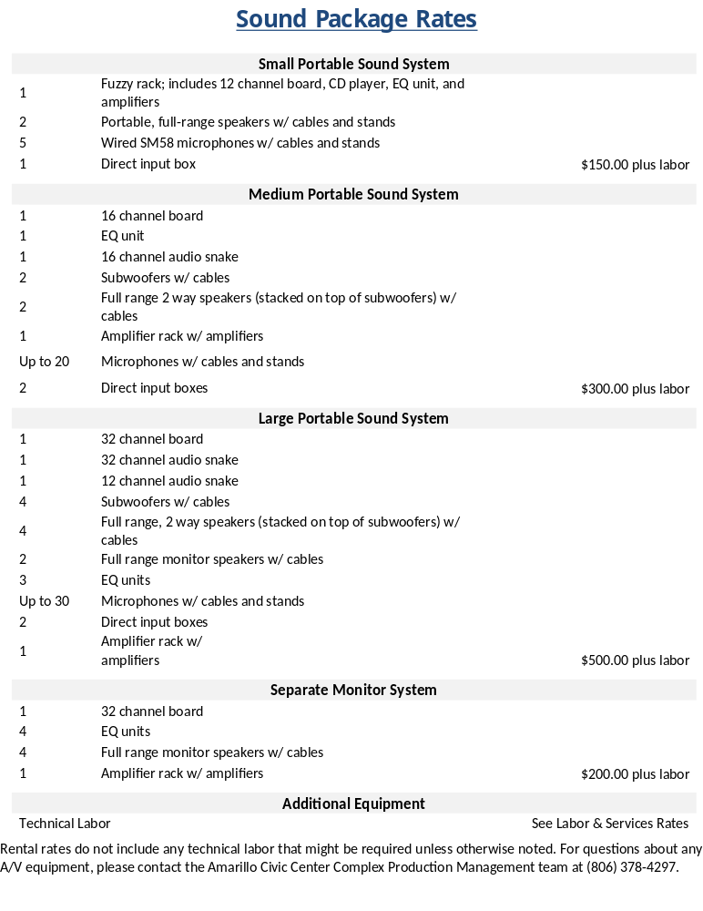

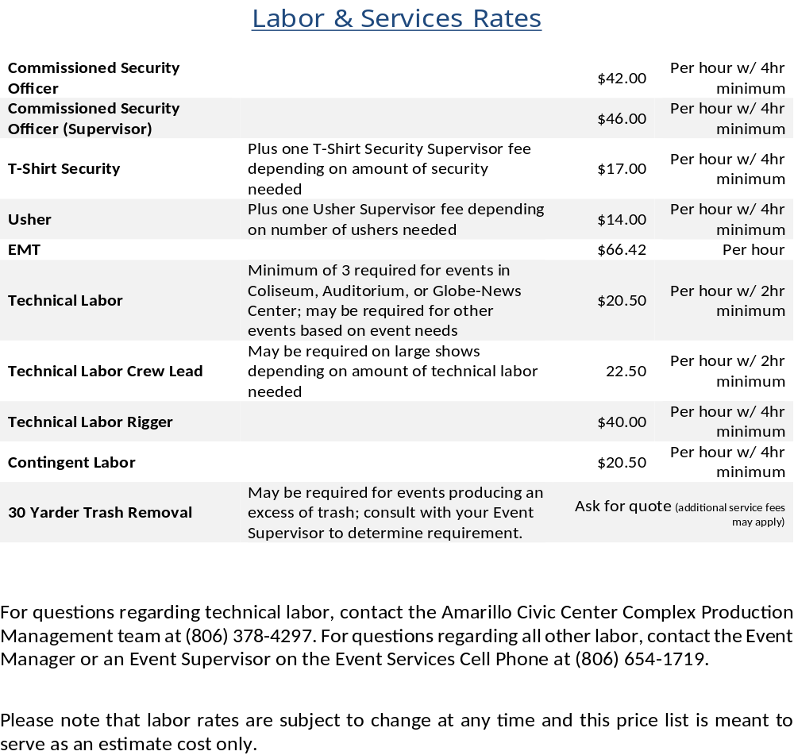

For questions regarding technical labor, contact the Amarillo Civic Center Complex Production Management team at (806) 378-4297. For questions regarding all other labor, contact the Event Manager or an Event Supervisor on the Event Services Cell Phone at (806) 654-1719.
Policies, rental rates, and equipment rental charges noted herein are subject to change without notice and supersede any
Version of this guide. This Event Planning Guide and its contents are incorporated by direct reference to your Lease Agreement. Circumstances and operations not covered in these rules and regulations will be subject to interpretations, stipulations, and decisions deemed necessary and appropriate by the Amarillo Civic Center Complex General Manager.

