Call for Artists and Entry Guidelines

CITY OF AMARILLO
The City of Amarillo – Parks and Recreation is issuing a Call for Artists to Amarillo - affiliated artists. The City of Amarillo Parks and Recreation Department has partnered with National Fitness Campaign (NFC) to install a Fitness Court in John Ward Memorial Park. As part of this project, the City is looking for digital artwork to be featured on its multipurpose training wall.

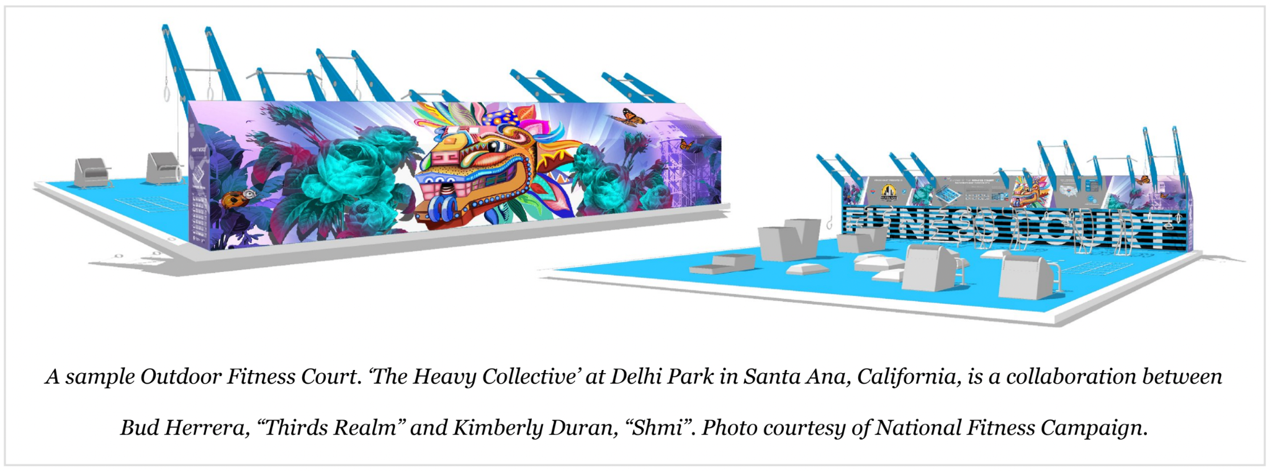

To learn more about the Fitness Court, click here: https://www.nationalfitnesscampaign.com/fitness-court

To see examples of past public art on the Fitness Courts, visit: https://nationalfitnesscampaign.com/local-artists

The Fitness Court mural wall will be 32 'L x 7' H in size and printed digitally on high quality anti-graffiti laminated vinyl. The front side of the Fitness Court training wall will also feature 4 small zones of artwork framing the Fitness Court usage and reference information. The two side panels of the training wall will feature the selected artist(s) headshot, logo, and short bio/description of the work. Please refer to the Local Artist Guidelines for further detail and photos supporting examples of how the artwork will be featured on the Fitness Court. As a selected local artist, you will be joining a network of over 30+ artists across the country who have participated in the campaign. See more information about the campaign and local artist participation at: https://nationalfitnesscampaign.com/local-artists

DEADLINE FOR SUBMISSIONS
May 29, 2026, 5:00pm Central Time

ELIGIBILITY
Applicants must live, work or study in Amarillo, Texas and be 14 years of age or older.

SITE INFORMATION
The Fitness Court will be installed at John Ward Memorial Park, 1100 Wallace Blvd. The City of Amarillo Parks and Recreation Department will be responsible for the cost of printing and installing the artwork and will require the local artist to attend the ribbon cutting and launch celebration once the Fitness Court opens to the public in Summer 2026, date TBD.

DESIGN CRITERIA
- Artists must be 14+ years old and provide a W-9. Minors under the age of 18 will need parental consent to enter the contest.
- Contestants may submit up to (2) two entries and must complete an entry form for each submission. Find the entry form on the final page of this document.
- The deadline for submission is May 8, 2026, at 5:00 p.m. Central Time. The City of Amarillo Parks and Recreation Department reserves the right to extend all deadlines associated with this contest.
- All submitted designs and images must be the original work of the contestant.
- No third-party artwork or images, including clipart or copyrighted graphics, may be used.
- Submissions must be made to cindy.perez@amarillo.gov
- Designs must be submitted digitally, in high resolution. Designs may be created with computer drawing programs OR traditional mediums that have been scanned into a high-quality digital version.
- Accepted file types are:
  - Adobe Illustrator (ai)
  - Adobe PDF (pdf)
  - Illustrator EPS (eps)
  - Scalable Vector Graphic (svg)
  - PSD, JPG or other rasterized graphics, needs to be the exact dimensions above at least 200 dpi, preferably 300
- Artwork & designs must incorporate the Fitness Court selected powder coating color: Pantone 2191C (NFC Cyan Blue)
- Artwork must not reference any fitness equipment that is not a part of the Fitness Court (weights, treadmills, etc).
- Artwork should promote positive imagery and represent local or regional values unique to the area. The goal is to share fun, vibrant, innovative artwork that tells the story of wellness and fitness in our community.
- Artwork must not condone violence or disturb the peace.
- Artwork must not include reference to playgrounds or young children. (This is for safety purposes to avoid confusion; this is not a children's playground)
- Artwork must not include reference to skateboarding or skate park imagery.
- Artwork does not serve as an advertisement for any brand or business.
- Artwork should not have any large phrases or words.

With the selected design:
- The City of Amarillo Parks and Recreation Department and NFC reserve the right to approve or reject any artist/design or make suggestions on final art.
- If applicable, NFC’s national/state-wide sponsors reserve the right to review final artwork submissions. Logos may be represented on the back wall alongside the artwork.
- The City of Amarillo Parks and Recreation Department and NFC may alter, modify or revise the submitted design as it sees fit to achieve the needs of the City. The selected artist will collaborate with NFC to fit artwork within Fitness Court design templates and standards.
- Contestants agree that the City of Amarillo Parks and Recreation Department, and the National Fitness Campaign may use their submissions and names for advertising campaigns and/or marketing materials in the future. The City of Amarillo Parks and Recreation Department and NFC reserve the right to share press & promotions of artwork and promote Fitness Court renderings or final install images on NFC’s website, social media channels, marketing collateral, and as an example to other campaign partners. NFC reserves the right to print and/or reprint artist artwork onto Fitness Court vinyl for application at selected and predetermined Fitness Court site location. NFC will not reuse artist designs for any other Fitness Court site location without the artist’s permission.
- The winning artist will retain the rights to their artwork and are free to reproduce it as they see fit.
- Artists will be invited to a launch event/ribbon cutting to promote art.
- Artist Grant Award will be mailed after artwork is installed.

The selected artist will be required to provide:
- High resolution digital files of artwork for back and front wall.
- Vector or high-resolution version of artist’s signature to be featured on the back wall in bottom left corner.
- Name/title of artwork to be featured on side panel wall
- 3-5 sentence artist bio to be featured on side panel wall
- High-resolution portrait of artist (200+ dpi, 9.5” x 9.5”) to be featured on side panel wall • Completed W-9 for grant allocation
- Address for grant check to be sent
- Social Media handles and/or personal website for promotion to be featured on NFC’s website: https://nationalfitnesscampaign.com/public-art

The selected artist will be paid a grant amount of $5,000 for the completed design upon final installation of the artwork by National Fitness Campaign.

Please contact Cindy Perez, if you have questions at: cindy.perez@amarillo.gov

Thank you,

Cindy Perez
Beautification and Public Arts Coordinator

SUBMISSION FOR CALL FOR ARTISTS
FITNESS COURT – JOHN WARD MEMORIAL PARK
NAME: ______________________________________________________________
BIRTHDATE: _________________________________________________________
ADDRESS: ___________________________________________________________
___________________________________________________________
PHONE NUMBER: ____________________________________________________
TITLE OF ARTWORK: __________________________________________________
ARTIST BIO (3-5 sentences):____________________________________________
______________________________________________________________________
______________________________________________________________________
______________________________________________________________________
______________________________________________________________________
IF SELECTED, DO YOU HAVE THE CAPABILITIES OF SUBMITTING THE ARTWORK INTO A HIGH-RESOLUTION VECTOR FILE? YES ___ NO ___
ARTIST SIGNATURE: ___________________________________________________

- Social Media handles hand/or personal website for promotion to be featured on NFC’s website.
- Contestants agree that the City of Amarillo Parks and Recreation Department, and the National Fitness Campaign may use their submissions and names for advertising campaigns and/or marketing materials in the future.
- The winning artist will retain the rights to their artwork and are free to reproduce it as they see fit.
- If selected, a Vector or high-resolution version of your signature will be required to be featured on back wall in the bottom right-hand corner.
- If selected, a high-resolution portrait of artist (200+ppi, 9x5” x 9.5”) to be featured on side panel wall.
- If selected, a completed W-9 for grant allocation. Artist Grant Award will be mailed after artwork is installed

